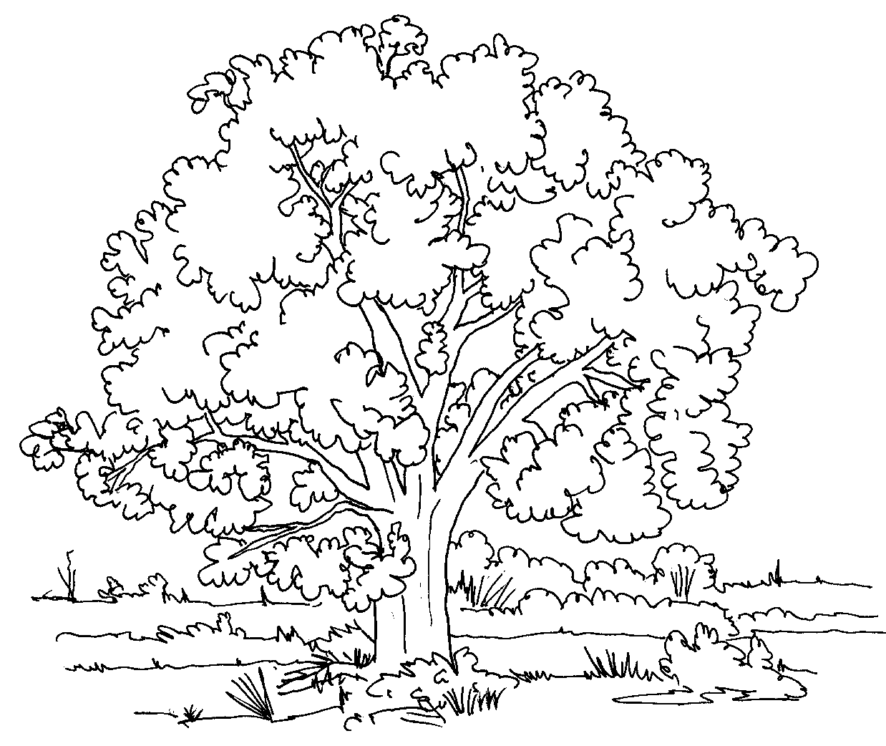
Name:
Lab Report Questions
- How can you tell the age of a tree that has been cut down? (You may want to draw a diagram to help explain.) How did we tell the age of the tree that was still standing?

- What does the diameter of a tree refer to?

- Why was it important for everyone to take their measurements at the same height, in our case at 1.5 meters, and on the same side of the tree?

- Why did you get a different diameter when using the calipers vs. the diameter tape vs. the ruler?

- Why is it important to track tree growth?

- Why are forest important for the environment? (Hint: CO₂)

- Could a forest be considered a home? Explain your answer.

- Do you think trees grow at different rates throughout the year? Explain your answer.

- Name 3 species that are classified as living that you learned about today.

